**GAME DESIGN DOCUMENT**

The Social Space

Multiplayer Social Cinema

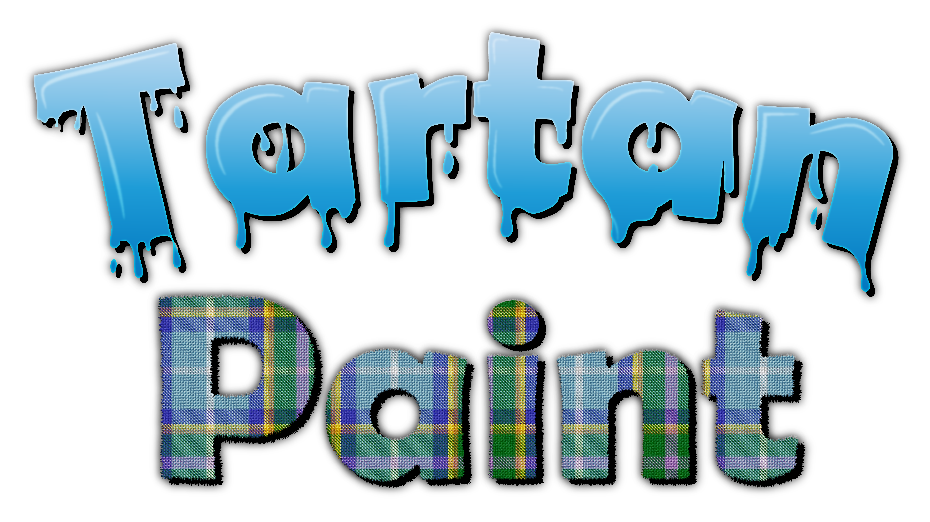

Tartan Paint Games Studio

**Last Updated:**

01/06/21

**Prepared By:**

Morgan Skillicorn

Producer / Lead Designer

**TABLE OF CONTENTS**

Game Analysis 3

Mission Statement 4

Genre 4

Platforms 4

Target Audience 4

Storyline & Characters 5

Character Concepts 6

Gameplay 7

Overview of Gameplay 7

Player Experience 7

Gameplay Guidelines 8

Level Design 8

Control Scheme Error! Bookmark not defined.

Game Aesthetics & User Interface Error! Bookmark not defined.

# Game Analysis

The Social Space is a multiplayer social space that can be experienced by large groups of people simultaneously. The initial prototype will be developed in Unity and include a cinema and lobby with the ambition to add support for other use cases in the future. The Social Space will be designed with customization in mind and the intention to be licensed out to third parties to run digital events such as digital film premieres, product launches and business conferences. The game will be hosted on a web server and be targeted primarily to Windows and WebGL with the website it is hosted on also supporting client login and customization. The client version of the game/social experience will be free to play with the server build available at several different tiers. A windows exe version of the game will also be available.

# Mission Statement

The Social Space is a place to connect with friends as well as a place to make new friends. The platform will enable communities to experience content synchronously and in an immersive manner online.

# Genre

* Social Space
* Multiplayer
* Casual
* Applied Game

# Platforms

* PC (Server and Client)
* Web GL (Client)
* Possible web interface to allow users to log in and customize their account and avatars
* Possibility to add other platforms later

# Target Audience

Anyone wanting to take part in immersive virtual experiences. The product will primarily be targeted towards individuals and organisations wishing to host digital experiences as the server build of the game will be the version that is sold with client builds available free in order to make the product accessible to a larger market.

# Storyline & Characters

The game will be themed around a futuristic cinema in a digital world that is populated by player avatars. Themed around 80s/90s retro Americana. The player characters will be mascot style avatars in the playable demo, but the idea of the project is that the aesthetics could be adapted to create virtual environments suitable for several commercial implementations. As this is a social game there is no “storyline” but a small narrative and environmental storytelling will help to build on the world and create a more immersive experience. The following page consists of concept art created by Ryan Geddes and is an example of the playable characters that will feature in the game.

## Character Concepts

 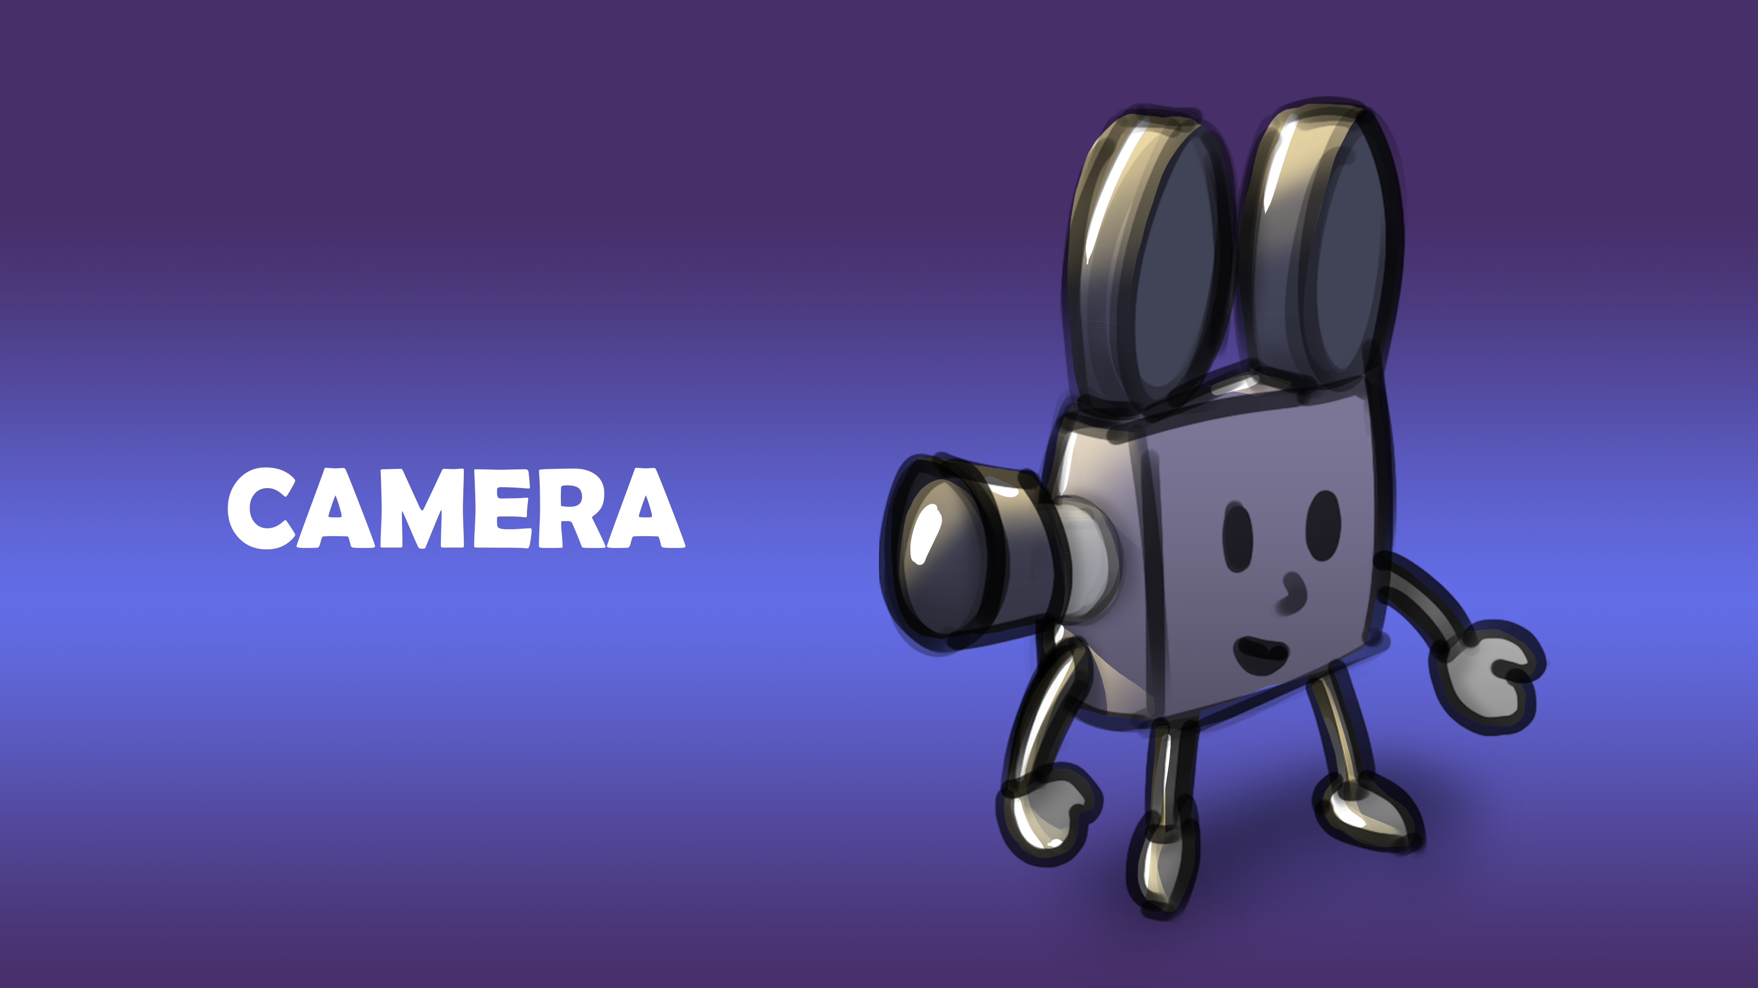

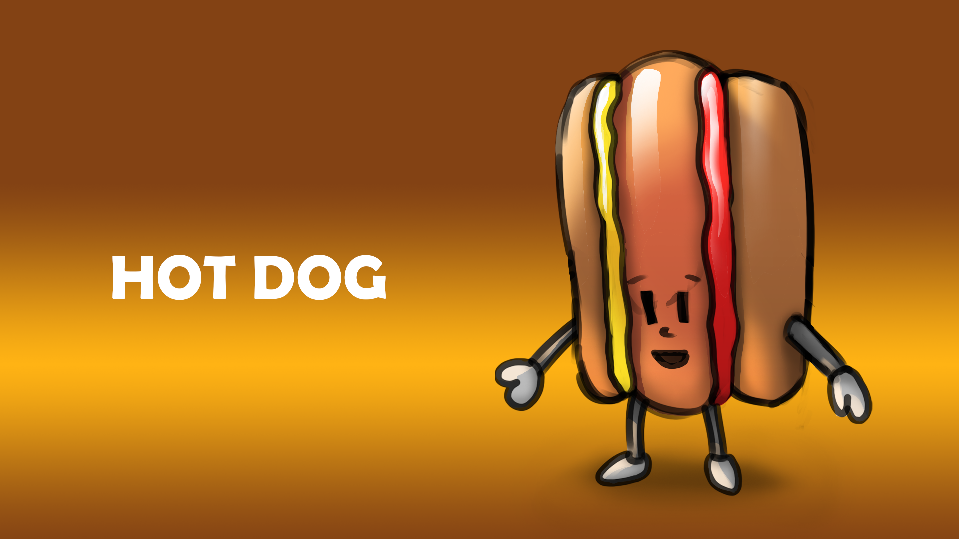 

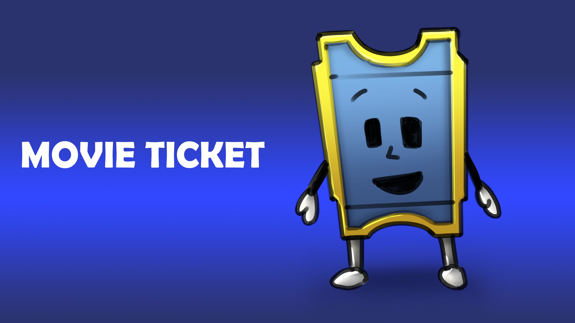 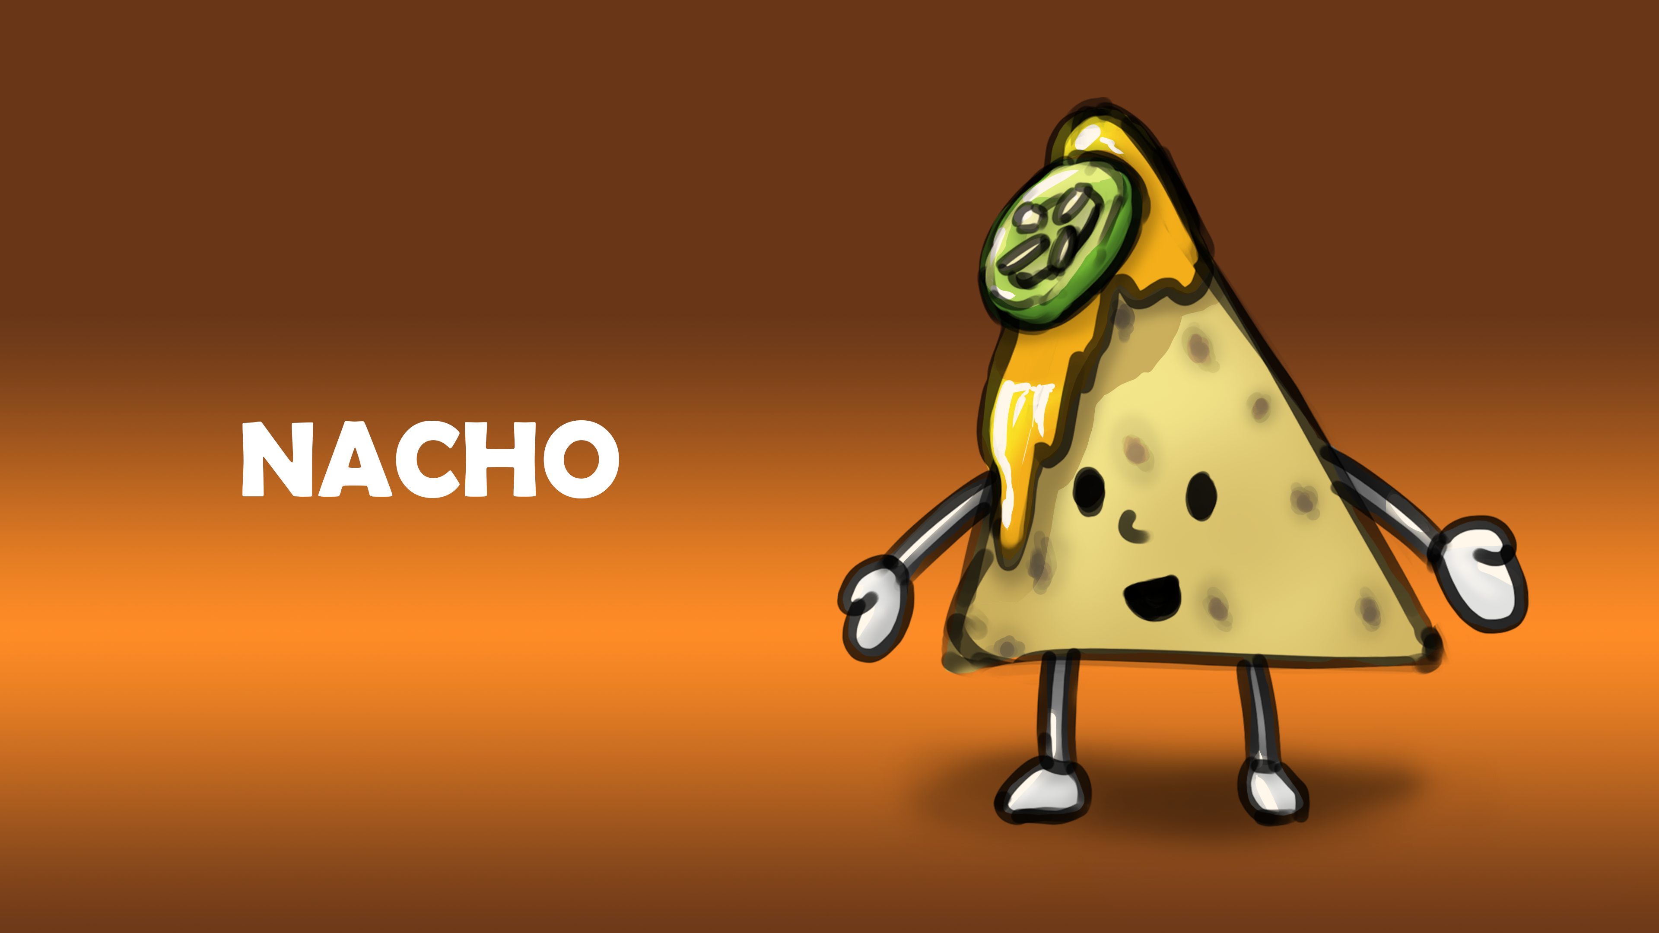



Concepts created by Ryan Geddes

# Gameplay

## Overview of Gameplay

The gameplay will take the form of a multiplayer social experience with players able to connect to a server (cinema) where they can watch a video on a screen synchronously with other players. The host will be able to manage the cinema on the server build and this will affect all the clients connected to the server. Minigames will feature in the world to help add to the social elements with things like popcorn being added that players can throw at each other to create a more fun and responsive world. The ability to disable some activities will be available through the server build and allow the host to create an experience suitable for their use case such as school classes and indie film premiers. Services such as YouTube, Vimeo and Twitch will be likely options to implement in the game to make it suitable for a large range of videos and make it more widely usable in different use cases. The WebGL build will allow us to drive web traffic allowing monetization and making it much more accessible on a larger number of devices without having to download and setup the game locally.

## Player Experience

You should feel immersed in the game and get the same feeling as when you sit down at the local Odeon before the latest blockbuster title begins. A rich environment with an appropriate aesthetic should surround you. You will open the client to see a menu with general settings and be able to connect to a server. To make this seamless the option to launch through a browser using launch arguments should be present on the windows version allowing fast connection to the server using links. In later iterations of the game customization options will be available on this menu screen with a cosmetics store. Once you have loaded into a server, you will find yourself in the hub/lobby where you can wander around with other players and partake in a number of activities. There will be a concession stand that you can interact with to purchase items such as popcorn that can be thrown at other players. Movies will be synchronized across all clients allowing you to enter a screen at a set time and watch a movie live with all the other players connected to the cinema. Overall, you should feel a sense of community and feel you are sharing an experience with the rest of the people connected to the server.

## Gameplay Guidelines

The Social Space should be an inclusive space suitable for a wide range of applications and should appeal to a wide range of communities/demographics. For this reason, the content in the base game should adhere to the ESRB rating for everyone. As this game will feature multiplayer gameplay at it’s core this will have to be factored in during development and relevant moderation tools implemented allowing the server host to set up their server in a way that is suitable for the community that uses it. Cosmetics that are implemented in the future will also need to consider this and should be suitable for the ESRB rating everyone. The content shown in the cinema rooms on individual servers will be curated by the server host allowing them to only show content that they feel is suitable for their community. Relevant copyrights and trademarks should be respected during development to ensure the game cannot be abused to show restricted content however this will mainly be the responsibility of the media hosting platforms such as YouTube or Vimeo.

## Level Design

The design of the environment will be heavily influenced by 80s/90s Americana with an overall aesthetic similar to that of the shopping mall that features in Stranger Things. All areas of the game will branch off of a central hub where players will spawn in and greet each other before heading to take part in events taking place in the branching areas.

|  |  |
| --- | --- |
| **Levels** |  |
| The Hub | Central area with a vast open area, decorated with various plants, billboards, and furniture. Should be able to accommodate branching areas in each direction. Themed around 80s/90s American cinemas and shopping malls. Billboards and advert screens around the hub should contain information relevant to the events taking place on the server such as show times. A concession stand should also be located in the hub where players can buy accessories and props to use while in the social space. |
| Cinema Room | A branching room connected to The Hub. The cinema room should be dark and be able to accommodate a large number of guests |

# Core System Technical Designs

## Cinema Screen

The Social Space will feature a screen which will be a 3D object. This screen will be textured with a material using a render texture. The system to use for this is called AVPro by Renderheads - <https://renderheads.com/products/avpro-video/>. The media player components in unity should be added to an empty game object and run independently of the physical screen. This will ensure the media player always exists and make it easier to sync between clients. For use in the demo prototype a video will be playing from a web source. There is no plan to implement any video switching mechanic at this time however the system should be designed with this in mind for the future.

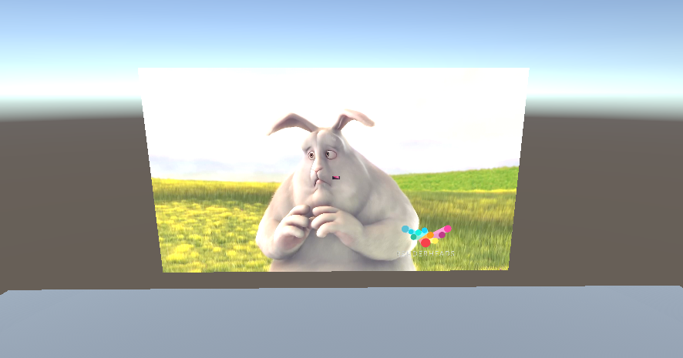

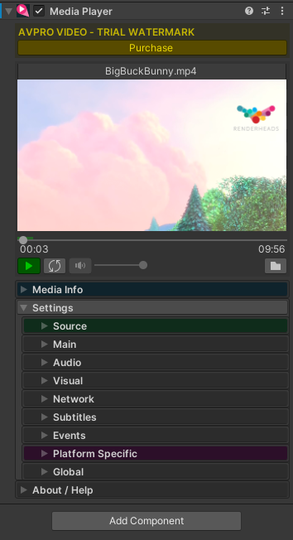

## Multiplayer Networking

The multiplayer system The Social Space uses will use Mirror and be heavily based on the implementation outlined in the quick start guide on their forum. It should be able to support multiple clients connecting to a single host at once with synchronized names and movements. More synchronization will be done in future iterations of The Social Space but for the sake of this prototype only movement and names should be synchronized. The ability to connect to a server via an external config file or command line argument should also be considered.

The systems key parts and components are outlined below.

